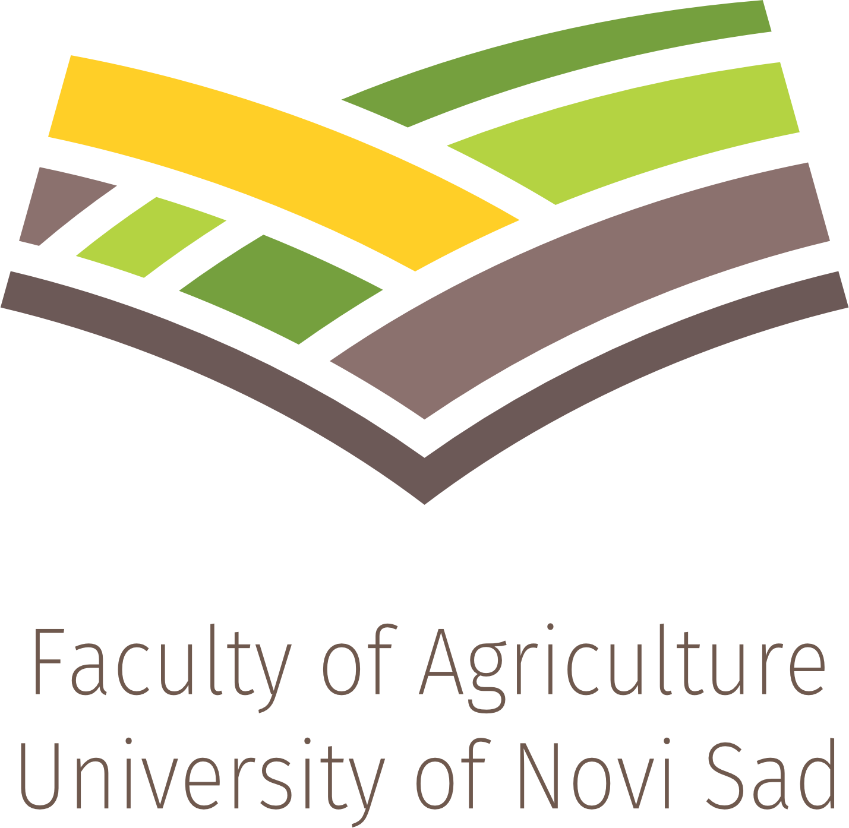

REGENERATIVE AGRICULTURE COURSE

APPLICATION FORM
Course period: 15 March – 15 June 2027
Please complete this form and submit it via email: irpo@polj.edu.rs
Full name and surname
Country
City
University / Institution
Passport number
Declaration
I confirm that the information provided in this application form is accurate and complete. I agree that the Faculty of Agriculture, University of Novi Sad, may use the information solely for the purpose of administering my application and participation in the Regenerative Agriculture Course.

__________________________ | __________________________
Date | Signature of applicant

